**Part 2 – Actor Component Architecture**

**Pack Mules**

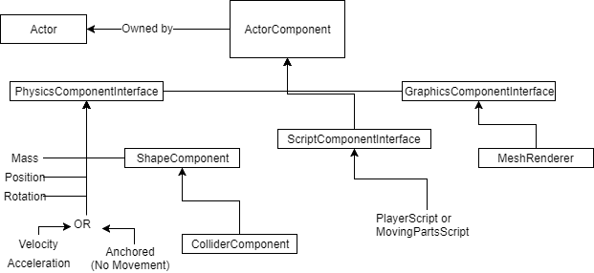

**Scale**

All actors have three component interfaces

1. Physics Component Interface
2. Script Component Interface
3. Graphics Component Interface

The **Physics Component Interface** is in charge of holding the position, the rotation, the scale and the mass of said actor. In terms of Unity, this would be the *Transform* component with parts of the *Rigidbody* component. In addition, it also contains a Boolean ‘Anchored’, which determines whether the object is capable of moving or not. If it is set to true, then velocity and acceleration will always be 0 no matter what collision it encounters. ShapeComponent is also used in here to determine whether the object is a rectangle, circle, triangle, or more. From this is also another collider that grabs the shape type, position, and rotation to determine the bounding collider box.

The **Script Component Interface** is used for moving objects. For the player ball actor, this would be ‘PlayerScript’, and would take in the player input and translate that into commands for movement. For moving obstacles/barriers in the mini-putt game, the MovingParts script will be a simple script that tells the type of movement to do (I.e. up and down, left to right, rotation). If there is no movement at all, then there won’t be any script in this location.

The **Graphics Component Interface** will be in charge of rendering the object into the world view by taking in the parameters from the Physics Component Interface.